CTD Post Processing Data Report (NABOS 2023)

Metadata
There are issues with the NMEA data feed reverting to Jan 1, 2000 for many of the stations. The date-time provided in the downcast file is pulled from the computer time (in UTC).

Temperature
We encountered issues with primary temperature (drift starting around station 38/39, Figure 1) that effects derived parameters like salinity and oxygen. There appear to be no issues with secondary temperature.
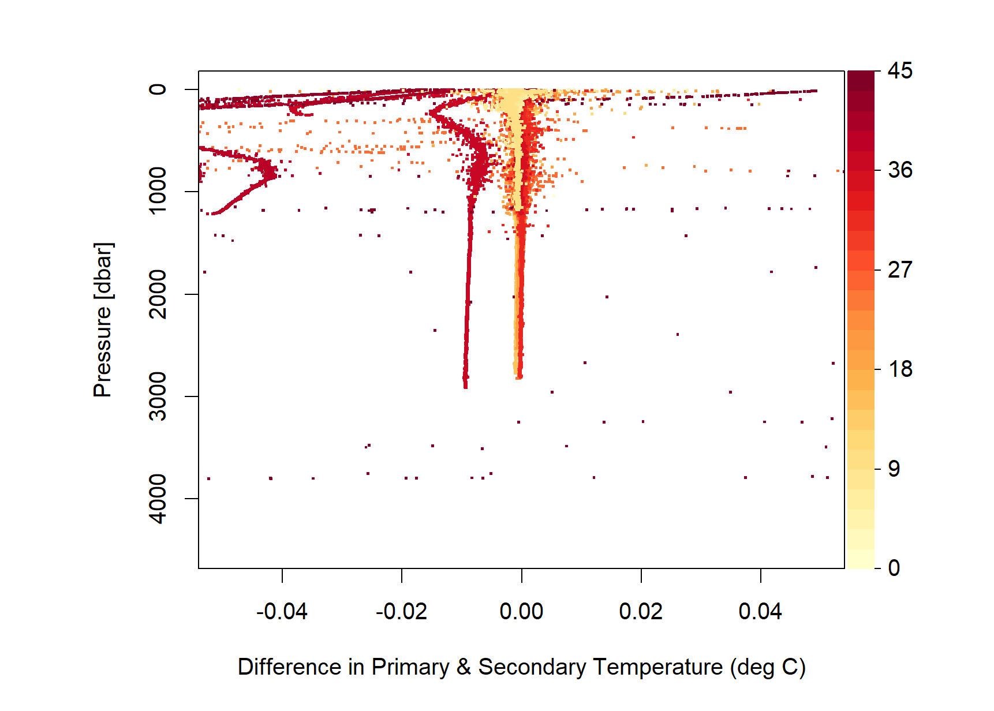
We note some large fluctuations in temperature (primary and secondary sensors) at the depth range of Barents Sea Branch Water (~600 – 1500 m) that may represent intrusions of water from the shelves or mixing between other water types. Throughout this sensor QC, we cannot find any indication that these features are due to sensor failure.
The secondary temperature data is reported in the final QC’d downcast and bottle file.
SENSOR REPORT: Temperature SBE-3plus 2796 (primary)
Report from Mason Schettig, STARC:
On our last CTD cast of the cruise, there appeared to be significant problems with the primary set of sensors. All primary parameters (except conductivity) showed synchronized spikes in the profile starting at 800m on the downcast. Nearly every 300-400m from that point on, a huge spike occurred in the Temperature, Salinity, and Oxygen profile for just the primary sensors. Eventually, the primary temperature sensor reached a point where it just displayed a value of 99.000ºC. Given that the primary dissolved oxygen and salinity values are derived using the primary temperature, it appears that the failure of one sensor (SBE-3plus) was throwing off the values of the other sensors.
***All ancillary sensors worked properly during these issues (fluorometers, transmissometer, altimeter)
Station 39 - Cast 1 - Upon further review, this was the first cast where a small drift occurred between the primary and secondary temperature sensor. During this cast (only 250m depth), the temperature difference reached a maximum of approximately 0.04ºC. This is well above optimal, as we usually expect a difference to be around 0.0005ºC - 0.001ºC. This difference increased with depth.
From Station 39 through Station 44 (6 casts total), the primary temperature slowly drifted in value from the secondary. If you plot this difference, you can see the value slowly increasing throughout the downcast. The problem grew subtly as we progressed through casts. These casts reached a maximum depth of 1200m. Station 45 was a bottom cast reaching a depth of 4048m. This massive increase in pressure could have potentially been the last straw, resulting in the complete failure of the temperature sensor.
After checking that all connections were well seated to the SBE-9 and all other sensors, I conducted a deck test. The primary temperature sensor still registered at 99ºC, so I powered down and swapped with a spare temperature sensor. The new value was stable and reasonable.
While breaking down the CTD package, I noticed the bulkhead connector being used for our primary temperature was slightly loose. This was only noticed after attaching a dummy plug and when the locking sleeve was fully engaged, the entire bulkhead connector started to rotate.
Ultimately, I have suspicion that there was water intrusion in the bulkhead connector. This would explain the increase in drift with depth, but not sure if it could potentially cause the SBE-3 to short out.

Conductivity
No issues were observed in the conductivity data.
We note some steps in conductivity (primary and secondary sensors) at the depth range of Barents Sea Branch Water (~600 – 1500 m) that may represent intrusions of water from the shelves or mixing between other water types. Throughout this sensor QC, we cannot find any indication that these features are due to sensor failure.
The secondary conductivity sensor data is reported in the final QC’d downcast and bottle file.

Salinity
The primary salinity values are corrupted by the drift & subsequent failure issues of the primary temperature sensor.
The secondary salinity data (derived from secondary conductivity + secondary temperature sensors) is reported in the final QC’d downcast and bottle file.

Oxygen
The CTD Oxygen data are processed outside of seabird and do not include a Tau correction. Specifically, there were complications with the Secondary Dissolved Oxygen sensor that resulted in it being replaced partway through the cruise. There is a large offset between the two secondary sensors used (serials: 0456 & 3296). No issues were observed with the primary oxygen sensor while at-sea, but the derived data are problematic because of the previously noted issues with primary temperature.
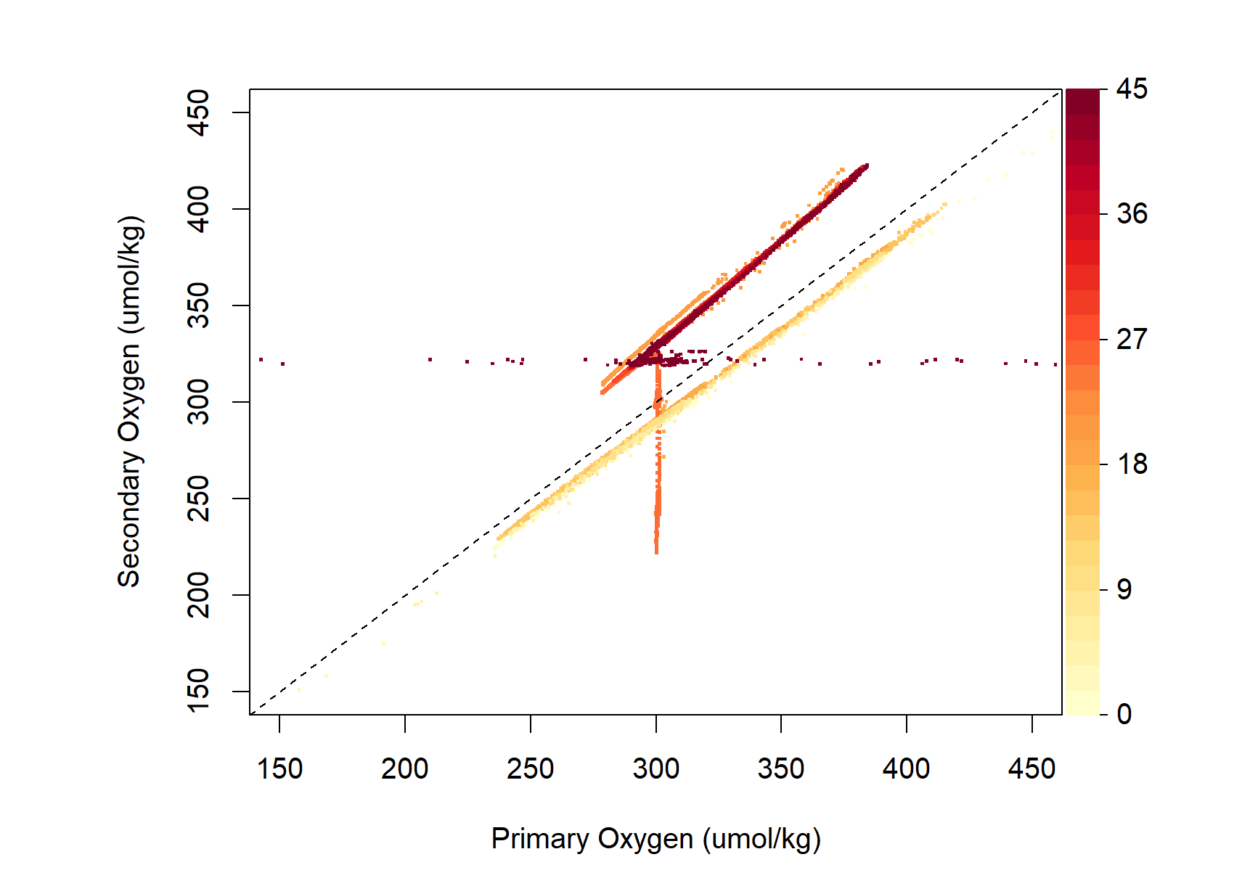
Using SBEDataProcessingTools, a hysteresis correction was conducted and oxygen voltage for both sensors was generated as well as oxygen in umol/kg without the Tau correction. Subsequently, In R (refs to github), the SBE Oxygen Calculations were conducted (without the Tau correction, see Equations) to permit the primary oxygen sensor to use the secondary temperature and salinity variables. This was conducted for both the downcast and bottle files. A linear regression with the Winkler calibration samples was then conducted between the Winkler vs. Downcast Oxygen and Winkler vs. Bottle Oxygen (from upcast) (Fig X). Although it is typical to use the Downcast for correction of the oxygen data, we noticed that the Bottle Oxygen had much better correlation with the Winkler data. This was largely due to large deviations at the surface of the water column in the downcast data (Fig X). For this reason, we use the Winkler vs. Bottle Oxygen linear regression to determine the correction factor for the downcast data. There is a roughly 8% offset between the Winkler data and the CTD data that is corrected in this manner.
The corrected CTD oxygen data is reported in the final QC’d downcast and bottle file.
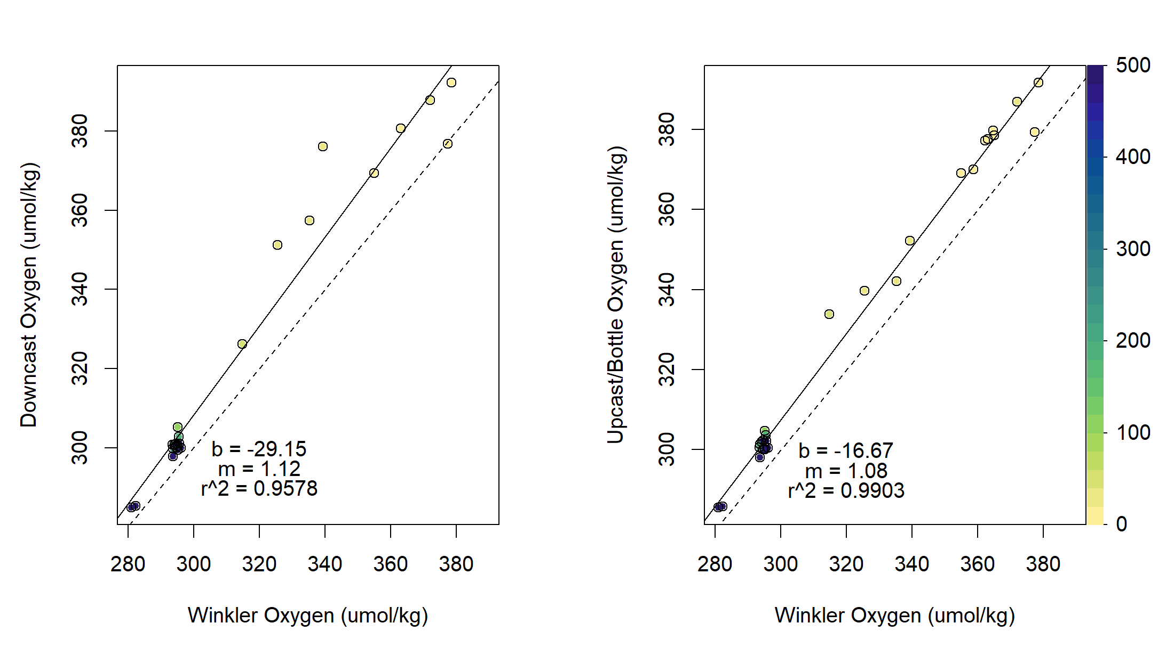

Equations
All original equations are found in the SBEDataProcessing Content and Index and Application Note 64-2. The conversion from voltage to mL/L in Application Note 64-2 has been modified to remove the tau correction:
$\left[Oxygen (mL/L)\right]=Soc*\left(V+Voffset\right)*Oxsol\left(T,S\right)*\left(1+AT+BT^{2}+CT^{3}\right)* e^{\frac{E*P}{K}}$)
Where Soc, Voffset, A, B, C, E are constants from the instrument calibration (check XMLCON file). V is the hysteresis-corrected voltage output. Oxsol(T,S) is the solubility of oxygen at the observed temperature, salinity, and pressure following Gordon and Garcia, 1992. K is the temperature in Kelvin. P is pressure in the water column.
Oxygen is converted from mL/L following the equation in the SBEDataProcessessing Content and Index. See reference github post for further details on the calculations used.
SBE-43 Dissolved Oxygen 0456 (secondary)
Report from Mason Schettig, STARC:
Station 7 cast 1 - The secondary oxygen followed the same trend as the primary, however, small spikes in the profile were noticed during the upcast and noted.
Station 8 through Station 17 - No noticeable spikes in the secondary plot, little to no difference from primary sensor
Station 18 cast 1 - During down cast, large spikes in the data were noticed in the secondary profile starting approximately around 580m. The overall trend of the plot was consistent with the primary sensor, but roughly 10 more smaller data spikes appeared in the cast and warranted attention. This led to swapping our secondary oxygen sensor with a freshly calibrated spare.
No further issues came up after the swap.
Chl Fluorometer
WetCDOM Fluorometer
Altimeter
Pressure
PAR
No PAR is reported in the final QC’d downcast or bottle files.
PAR Sensor (s/n 70682)
Report from Mason Schettig, STARC:
On the first few casts of the cruise, it was noticed immediately that the PAR sensor seemed unresponsive while conducting casts during daylight hours. There were small changes in the dataset during the upper 300m of the upcast, but the values were far too low and on future casts the values held closely to zero. We tried placing the PAR on its own channel to remove it from a split channel, but that led to no changes in the performance. While conducting a decktest using an LED flashlight, we still saw little to no change in the value when this should easily force a max voltage on the sensor. After consultation with the science party, we removed the PAR after Station 4 cast1 as it was not a primary focus of their dataset. Additionally, there is no spare PAR onboard.
Other CTD Operational Notes
Report from Mason Schettig, STARC:
On a side note, on Station 34_Cast1, we noted an accumulation of 2 modular error counts. This does raise an eyebrow, but no future modular errors occurred on any future casts.
Insert Seabird post-calibration notes.

